ADITYA COLLEGE OF ENGINEERING AND TECHNOLOGY
Department of Computer Science and Engineering
V SEMESTER — B.TECH
A Project Report On
HouseHunt
AI-Enabled Smart House Rental Platform Using the MERN Stack
Submitted by
Name | Role
Charan Vengaladasu | Team Lead
Tummuri Uma Bhargavi | Member
Gedala Chaitanya | Member
Bangaru Hema | Member
Geddamuri Madhavi | Member
Technology Stack
React.js · Vite · Tailwind CSS · Node.js · Express.js · MongoDB · JWT · AI Recommendation Engine
Academic Year 2026

1. Introduction

1.1 Project Title
HouseHunt – AI-Enabled Smart House Rental Platform Using MERN Stack.

1.2 Team Members
Name | Role
Charan Vengaladasu | Team Lead
Tummuri Uma Bhargavi | Member
Gedala Chaitanya | Member
Bangaru Hema | Member
Geddamuri Madhavi | Member

2. Project Overview

2.1 Purpose
HouseHunt aims to modernize the property rental discovery process by combining a full-stack MERN application with an AI layer that understands natural language queries and personalizes results. Instead of relying solely on rigid filters, users can describe what they are looking for in plain language, and the platform intelligently surfaces the most relevant listings for tenants while giving property owners an efficient way to reach genuinely interested renters.

2.2 Features
- AI Chat Assistant that helps users search for properties using natural language.
- Personalized property recommendations based on user preferences and interaction history.
- Smart filtering using AI for budget, location, amenities, and property type.
- Conversational search as an alternative to traditional filter-only search.
- Faster, more user-friendly property discovery with a responsive interface.
- Secure, role-based authentication for tenants, owners, and administrators.

3. Architecture

3.1 Frontend
The frontend is built using React.js with Vite as the build tool, and styled using Tailwind CSS. It follows a component-based architecture with reusable UI components such as property cards, search bars, filter panels, and the AI chat widget, along with client-side routing for pages including Home, Search Results, Property Details, Dashboard, and the Chat Assistant.

3.2 Backend
The backend is implemented using Node.js and Express.js, following a layered structure that separates routes, controllers, services, and models. The AI module is integrated as an independent service layer that controllers invoke for recommendation and natural-language-query handling, keeping business logic modular and maintainable.

3.3 Database
HouseHunt uses MongoDB, a document-oriented NoSQL database accessed through Mongoose. The core collections are summarized below.
Collection | Key Fields | Description
Users | _id, name, email, passwordHash, role | Stores tenant, owner, and admin account details
Properties | _id, ownerId, title, location, price, amenities | Stores property listings and their attributes
Bookings | _id, propertyId, userId, status, dates | Tracks booking and reservation requests
ChatSessions | _id, userId, messages, preferences | Stores AI chat assistant conversation history
Recommendations | _id, userId, propertyIds, score | Stores computed personalized recommendations

3.4 ER-Diagram
The entity-relationship diagram below shows how Users, Properties, Bookings, and the AI-related collections relate to one another.
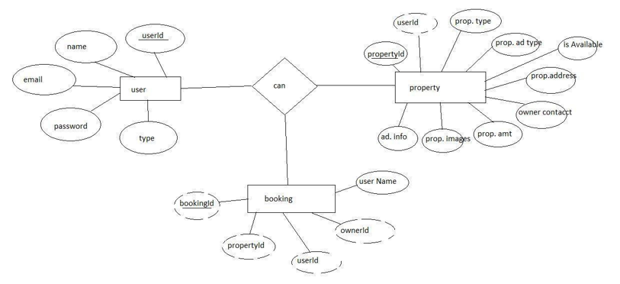
Figure 3.1 — Entity-Relationship Diagram of the HouseHunt database

3.5 AI Module Architecture
The AI module is composed of two primary components. The AI Chat Assistant accepts natural language input and parses it into structured search parameters such as location, budget range, property type, and desired amenities, maintaining conversational context across follow-up queries. The Personalized Recommendation Engine analyses user interaction signals — viewed, saved, and booked properties — along with explicit preferences captured through the chat assistant, to rank and surface the most relevant listings using a hybrid of content-based filtering and behavioural signals.

3.6 System Architecture Diagram
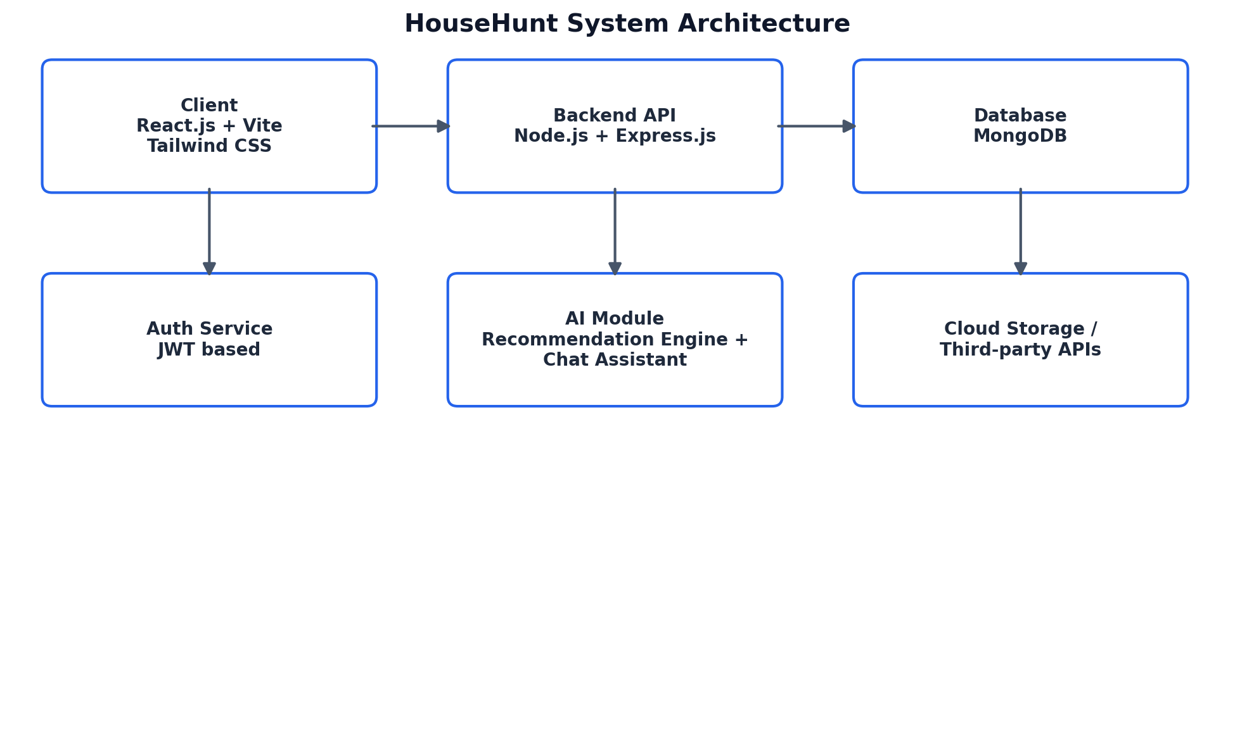
Figure 3.2 — High-level system architecture of HouseHunt

4. Setup Instructions

4.1 Prerequisites
- Node.js (v18 or later) and npm installed
- MongoDB (local instance or MongoDB Atlas cloud cluster)
- Git for version control

4.2 Installation
- Clone the repository: git clone <repository-url>
- Navigate to the server directory and install dependencies: cd server && npm install
- Navigate to the client directory and install dependencies: cd client && npm install
- Create a .env file in the server directory with variables such as MONGO_URI, JWT_SECRET, and PORT
- Create a .env file in the client directory with the API base URL, e.g. VITE_API_URL

5. Folder Structure

5.1 Client (React Frontend)
client/src/components — reusable UI components (PropertyCard, SearchBar, ChatWidget, FilterPanel). client/src/pages — route-level pages (Home, Search, PropertyDetails, Dashboard, Login, Register). client/src/context — global state providers for auth and search context. client/src/services — API service functions for communicating with the backend. client/src/assets — images, icons, and static resources.

5.2 Server (Node.js Backend)
server/routes — API route definitions grouped by resource (auth, properties, bookings, chat). server/controllers — request handlers containing endpoint logic. server/models — Mongoose schema definitions for MongoDB collections. server/services — business logic, including the AI recommendation and NLP service. server/middleware — authentication, validation, and error-handling middleware. server/config — environment and database configuration files.

6. Running the Application
- Frontend: npm start in the client directory (or npm run dev, as configured with Vite) — typically served at http://localhost:5173
- Backend: npm start in the server directory (or npm run dev for hot reload) — typically served at http://localhost:5000
- Ensure MongoDB is running locally or that the Atlas connection string is correctly configured before starting the server

7. API Documentation
The backend exposes RESTful API endpoints grouped by resource. Selected core endpoints are summarized below.
Method | Endpoint | Description
POST | /api/auth/register | Register a new user (tenant, owner, or admin)
POST | /api/auth/login | Authenticate a user and issue a JWT
GET | /api/properties | Retrieve a list of properties with optional filters
GET | /api/properties/:id | Retrieve details of a specific property
POST | /api/properties | Create a new property listing (owner only)
POST | /api/bookings | Create a booking request for a property
GET | /api/bookings/:userId | Retrieve bookings for a given user
POST | /api/chat/query | Send a natural language query to the AI chat assistant
GET | /api/recommendations/:userId | Retrieve personalized property recommendations
Each endpoint accepts and returns JSON payloads. Protected endpoints require a valid JWT to be included in the Authorization header as a Bearer token.

8. Authentication
HouseHunt implements stateless authentication using JSON Web Tokens (JWT). Upon successful login or registration, the server issues a signed JWT containing the user's identifier and role, which the client stores and includes in the Authorization header of subsequent requests.
- Passwords are hashed using a secure hashing algorithm before being stored in the database.
- JWTs are verified on the server using middleware before granting access to protected routes.
- Role-based access control differentiates permissions for tenants, property owners, and administrators.
- Tokens are configured with an expiry period, after which users are required to re-authenticate.

9. User Interface
Key screens of HouseHunt include the Home page with search and AI chat entry points, the Featured Properties listing view, and the Login page for secure access.

9.1 Home Page
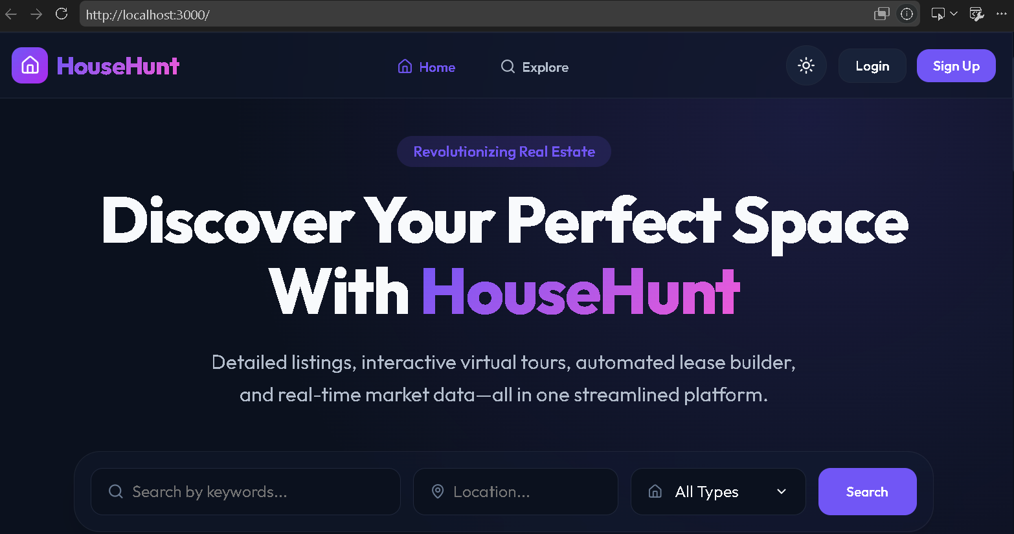
HouseHunt Home Page (Hero Section)
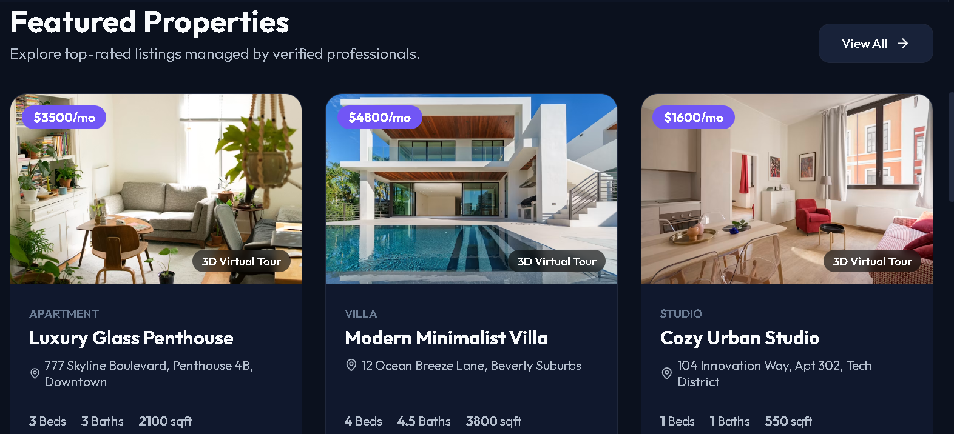
Figure 9.2 — Featured Properties Listing

9.2 Login Page
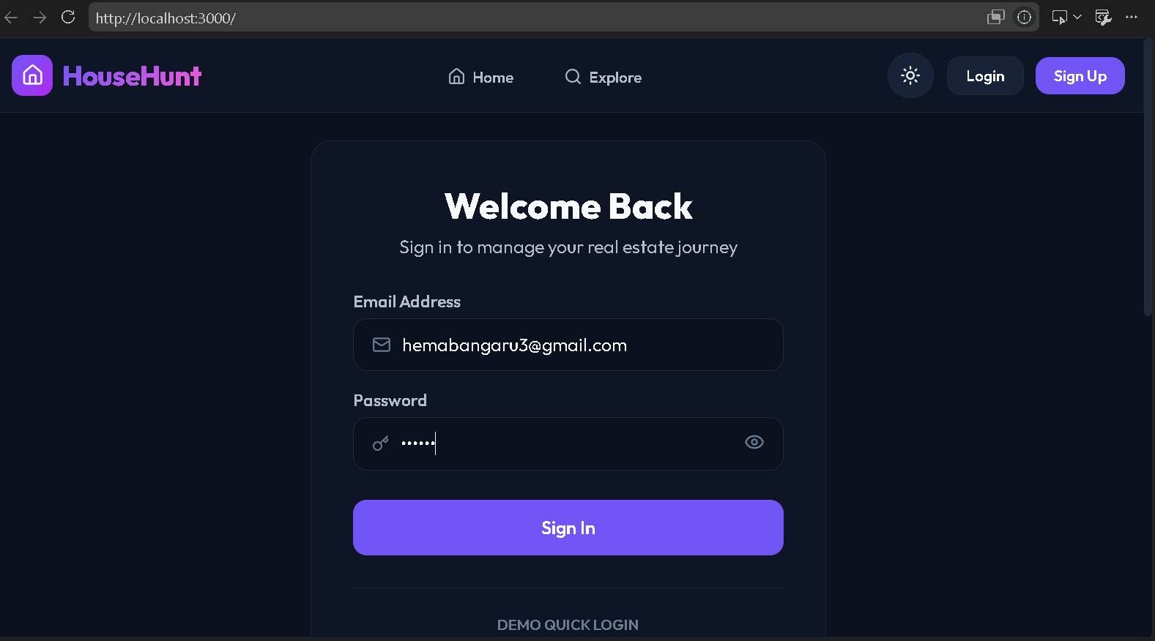
Figure 9.3 — HouseHunt Login Page

10. Testing
A combination of manual and automated testing strategies was used to validate the functionality, reliability, and security of HouseHunt.
Testing Type | Description
Unit Testing | Individual functions and components tested in isolation (e.g., controllers, utility functions)
Integration Testing | API endpoints tested for correct interaction between routes, controllers, and the database
UI Testing | Manual testing of frontend components across different screen sizes and browsers
AI Module Testing | Validation of chat assistant query parsing accuracy and recommendation relevance
Security Testing | Verification of JWT validation, password hashing, and role-based access restrictions

11. Screenshots or Demo

11.1 Video Demo
Demo video:
https://drive.google.com/file/d/1oRKe3N06jLUUHKny7D0wVK_SQK42342F/view?usp=sharing

11.2 Application Screenshots
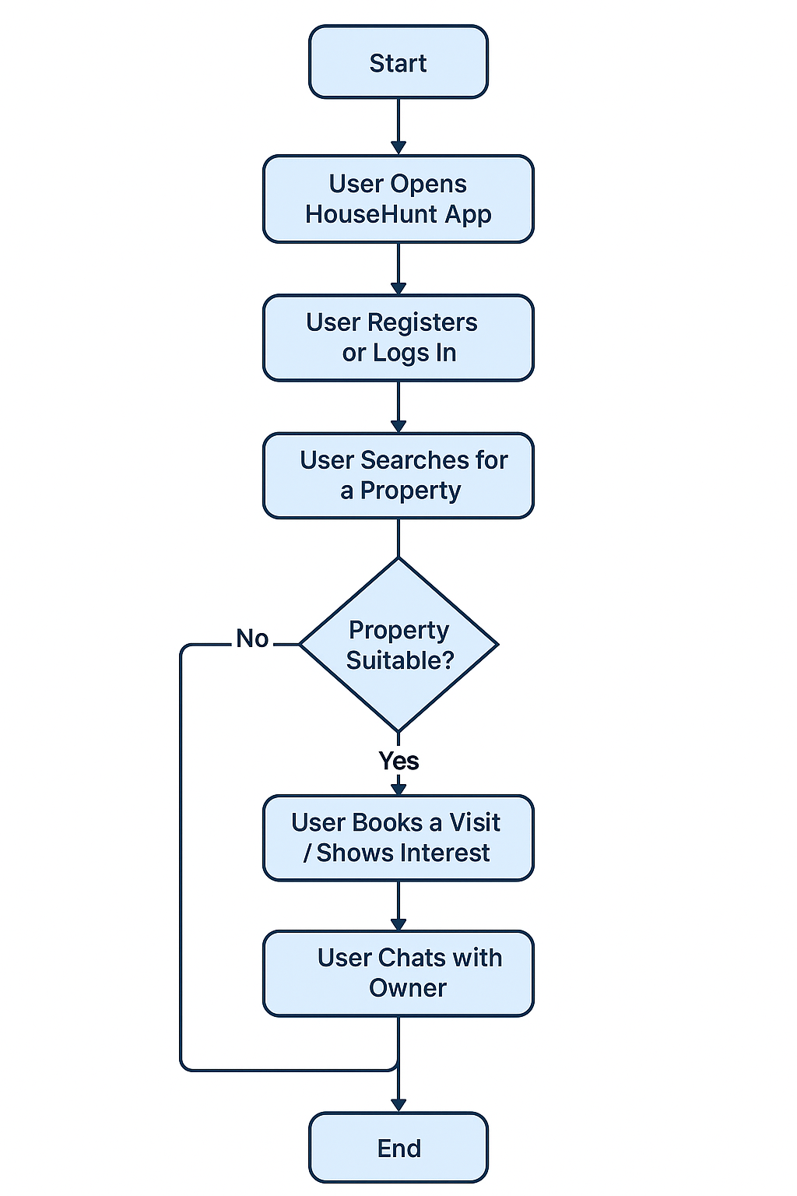
Figure 11.1 — Application screenshot

Figure 11.2 — Application screenshot
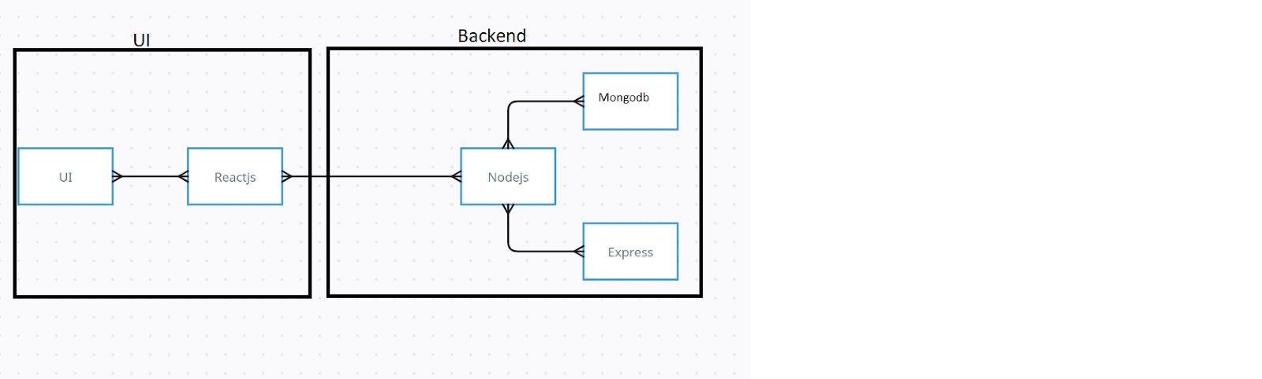
Figure 11.3 — Application screenshot

12. Known Issues
- The AI recommendation engine requires sufficient user interaction data to generate highly accurate personalized suggestions for new users.
- The chat assistant's natural language understanding may face challenges with highly ambiguous or complex queries.
- The current implementation does not include real-time payment gateway integration for bookings.
- The system has not yet been load-tested with a high volume of concurrent users.

13. Future Enhancements
- Integration of a real-time payment gateway to support end-to-end booking and rent payments.
- Enhancement of the AI chat assistant with voice-based interaction support.
- Addition of a map-based property search using geolocation services.
- Implementation of a review and rating system for properties and owners.
- Deployment of the platform on a scalable cloud infrastructure with CI/CD pipelines.

